MEAL outline for writing paragraphs

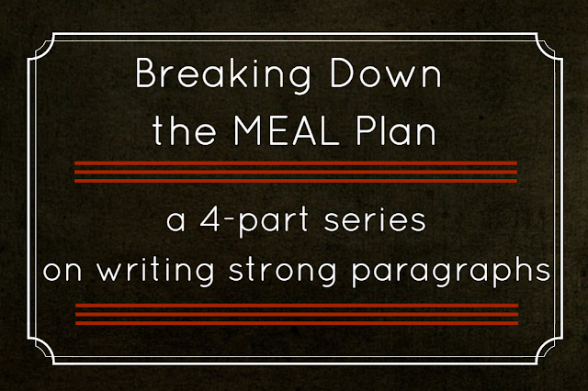

Good paragraphs start with a topic sentence in your own words (no citation).

The M stands for Main idea. Put the topic sentence/main idea of the paragraph in the first sentence.

The E stands for Evidence (think sources/citation to support your topic sentence). The second and perhaps third sentence should present evidence to support your topic sentence.

The A stands for Analysis. You should analyze the evidence in your own words.

Finally, the L stands for Lead out sentence, into the next paragraph. The best scholarly writers have transition sentences that lead nicely conclude the paragraph and lead into the next paragraph and topic sentence.

Source http://academicguides.waldenu.edu/writingcenter/paragraphs/organization

